Highbury South Allotment Association

Minutes of the AGM 26th January 2023 – 19:00

Empire Club, First Floor, 32-34 Salters Road, Gosforth

Present: There were 28 members present, including the committee members. Bob Heyman was Chairman.

Bob welcomed everyone to the meeting and expressed his thanks to members for turning out in poor weather. Apologies for absence were given to Pam.

Apologies for absence: Ruth Husband, Tim Cook, Gail Preston, Edward Smith, Pip Harrison, Andy Agate, Robin Seymour, Mary and David Robinson, Richard Innes, Mima Cattan, Jean Audsley, Dorothy and William Bateman, Sylvia Marshall, Martin Jenkins, Anne Paton, Jill Davison, Alison Proudfoot, Lucy Clark, Nicola Sugden, Carol Smith, William Hodgkinson, Gavin and Joan Aarvold, Monica and Alan Dordoy, Fiona Clarke.

Minutes of 2022 AGM and matters arising.
The minutes of the 2022 AGM were presented to the meeting and were adopted. It was suggested the 2023 AGM minutes should be posted as soon as possible in DRAFT form only.
There were no matters arising.
CHAIR'S REPORT
Bob Heyman

The Year 2022-2023
Our allotment-keepers enjoyed a year free of Covid restrictions. After a cold spring, we experienced a long, warm and dry summer and autumn. Watering was required, but crops of soft fruit, runner and French beans, squashes and apples were magnificent. Our large apple surplus allowed many crates to be donated to local foodbanks. Slugs, snails and greenflies were not a problem this year, although leek crops were damaged by leaf miners. It is tempting to welcome the greater chance of hot summers in our chilly region resulting from the climate emergency. However, experts tell us that the glut of apples is a stress response to drought - resulting from the trees doing their best to reproduce before they die of thirst. A wet autumn and winter were required to save them, and, happily for us, occurred this year. We may not be so lucky in the future.

This year, control of our site was transferred from Urban Green Newcastle (UGN) to the Freemen of Newcastle. Our association had no choice in this transfer. Members are unlikely to notice much difference, but there are financial implications which our Treasurer will explain in more detail. When Newcastle Council managed most allotment sites, support was provided by the Newcastle Allotment Working Group which worked closely with the allotment officer on behalf of all allotment associations in our city with respect to issues such as governance, insurance, waste, security, water supply, tree-management and the Newcastle Show. Responsibility now appears to be fragmented between UGN, the Freemen and Newcastle Council. It remains to be seen how this arrangement will work out, but it is a good bet that HSAA will need to be as self-reliant as possible.

Highbury South Allotment Show and Barbecue
Edmund Smith and Bob Heyman organised our annual Show. (The Newcastle Show was cancelled this year for various reasons.) Despite untypically mixed weather, the Show was a great success, one of the best ever in terms of attendance and the quality of exhibits. Particular thanks are due to David and Joe Callan for providing a magnificent barbecue, a task which involves them in an enormous amount of work. Some members felt that they would prefer the Show to be earlier (it was held on 25/09/22). However, the date is determined by practical constraints, particularly the availability of key individuals and the timing of the Newcastle Show. Our policy is to hold it as early in September as possible.

Edmund judged the exhibits apart from his own which Bob judged! (We plan to have more judges next year.) Congratulations are due to prize-winners:

 | First | Second | Third
Best gardeners | School | Anne Noble | Sasha Pervin
Art <17 | Martha Mounsey | Robyn
Art 17+ | Liz Todd | Alan Dordoy | Pam Brown
Blog 17+ | Monica Shaw | Bob Heyman

Full details of prize-winners in each category can be found on our website (https://www.highburysouthallotments.com/post/annual-show-2022) along with a splendid, professional quality video produced by Chris Sutcliffe. Congratulations also to Sasha Pervin for winning third prize in the Newcastle-wide competition for best quarter plot.

Your Committee
The Highbury South Allotment Association Committee which I chair had some difficulty getting through its business during the early part of the year. We eventually decided to streamline our discussions by inviting officers to submit brief written reports in advance which has resulted in meetings running much more smoothly, allowing us to consider larger concerns such as environmental issues. By chance rather than policy, all the Committee members have specific roles, and this may also help the Committee to run more effectively. Bob gave special thanks to the officers newly appointed in 2022 and singled out Pam for doing an excellent job as membership secretary, to Roger as a very able treasurer and Olga for being a fantastic bulk supplies officer.

We have, in my view, a particularly effective group of officers, some fairly new and some longstanding, as Committee membership gradually turns round. I would like, on behalf of the Association, to offer thanks for their hard work over the year to: Stephen Tyrer, our Secretary, Roger Blight, Treasurer; Pam Brown, Membership Secretary; Jo McSwaine and Tim Parsons, Website Managers; Chris Sutcliffe, Equipment; David Callan, Catering; Meryl Wakeman, Paths and Green Spaces; Olga McFall, Bulk Supplies; Tim Cook, West Jesmond School and Community Gardens Liaison. Thanks are also due to Jenny Wigston, Joan and Gavin Aarvold and all the volunteers who keep the community garden in good shape for the benefit of children at West Jesmond School and others. They also look after the recreation area for the benefit of all. Finally, thanks are due to all of the many volunteers who attended working parties or helped individually to keep our site in good shape. Without members' active support, the Association could not manage its estate. Bob closed by saying the committee were committed to considering environmental issues and Chris will discuss this further in his report.
Secretary’s report
Stephen Tyrer

It has been an eventful year for Highbury South Allotment Association. After strong winds in January, we sustained an array of broken fences but as described by Chris Sutcliffe, who will be speaking later, we managed to repair these ourselves and by doing this, the association saved between £1000-£1400. There has also been a major change in the ownership of our allotment from Urban Green to the Freemen as mentioned by Bob.

As is customary we have had three working parties during the year. The reason for having a working party is to carry out relatively major changes to the site which cannot be managed by one or two individuals. The tasks involve include cutting down shrubs, pruning trees, attending to neglected plots and making improvements to the site. Stephen stressed the value of the working parties in making our site attractive and tidy.
All plot holders are encouraged to attend at least one working party a year. This is a vital resource. It is appreciated if those who cannot attend a working party request other jobs to be done at their convenience.

There have been reports of rabbits on the site but although we arranged for action to be taken against them no trace of the rabbits could be found at the time. So far this has not been a serious problem; there has not been a great deal of damage reported from rabbits. It is still important to let Stephen, via Pam, know of sightings and a member said he had seen them mid-way along the southern fence recently.

We now collect regular deliveries of coffee ground waste which is both a good fertiliser and slug repellent. Stephen thanked Tim for collecting the bags.

Fires – in 2022 there were complaints from neighbouring residents about the effect of smoke on their washing and the impact on climate change. Stephen asked people to consider the wind direction when having their individual fires as will be the case for the large communal fire at the time of the Working Parties. All plot-holders should consider wind direction when starting fires and if these are posing a problem the members who have started fires should be advised to put them out. The association hope to rent a chipper, possibly with Highbury North, to dispose of wood and create our own woodchip.

I endorse the comments of our Chairman about the excellent relationship between all members of the committee, each of whom play an essential part in our organisation.

AGM Treasurer’s Report
Roger Blight

Roger produced management reports on the association’s bank balance. The Bank Balance at 31st December is £8,594 (compared the prior year £7,684).
However, the current balance excludes a site rental payment of approx. £1,092 – owing to our new Landlord the “Freemen” from 1st October 2022). So, a more realistic year-end balance is £7,502 – as shown on the Accounts.
How much do we get in?
- Annual Income- £8,793 including subscriptions £7,310 with an additional £935 coming from Joining fees (currently £50 per plot) and Greenhouse trading. Raffle income and key income make up the remainder.
Where does it go?
- Rents and Insurances £3,100
- Catering at Annual show and working parties £1,500 (including £574 from prior year)
- Repairs (mainly fencing, wood and concrete) and new raised beds (wood etc) £1,300.
- Skips £900 (£300 each)
- Manure, Soil conditioners and woodchip £500
- Repairs to Equipment £200
- New Equipment £300
- Prizes for Annual Show £200

Membership Secretary’s report
Pam Brown

Allotments
There are currently 63 families waiting for a plot at Highbury South. Although this figure is higher than the 2022 AGM reported figure of 55, the waiting list has been as high as 74 at some point this year.
Nevertheless, there has been a lively amount of change from January to December 2022. In total, there are now twenty-one new families now gardening at Highbury and a further nineteen people removed from the waiting list who have either moved away or acquired plots elsewhere.
The next person to contact on the waiting list applied in June 2021.
I do advise everyone who applies for an allotment to also apply to other sites as I estimate a three-year wait is likely for a plot on our site.
Inspections
All three 2022 planned inspections went ahead with the addition of three interim inspections. These were return inspections a month after the main ones to ensure improvement.
Nursery beds
In 2022, we created 8 ‘Nursery beds’, approximately 3.5 x 1 metres, in the SW corner of the site.
Firstly, a huge thank you to everyone who was involved in building these beds, ordering, and taking delivery and transporting the wood, as well as keeping the beds weed-free when necessary.
This initiative was developed to allow some folk on the long waiting list a chance to grow their own produce, see if they enjoyed gardening and tend a plot of their own.
Three of the beds were given over to asylum seekers and the remaining 5 nursery bed tenants have now moved on to rent half or quarter plots.

Bulk Supplies
Olga McFall

Olga McFall took over the bulk supply officer position in August 2022. Since then, there have been 2 full loads of manure (Sep. Nov.) and plenty of woodchip (Sept. Oct. Nov. Dec.); one of these deliveries was free of charge. Olga asked that members should avoid obstructing the Jesmond Dene Road gate with parked cars as deliveries of woodchip usually arrive unannounced by suppliers who have their own gate keys. Both manure and woodchip deliveries are discontinued in the height of summer due to the heat and the trees in full leaf.
Olga does leave notes at the gate when deliveries arrive as well as informing the web-team to add to the website.

Catering
David Callan

David reported that the working parties and annual show were well attended and where possible, hot food is preferable to a cold buffet. Due to the unpredictability of the weather, it is safer to stick with the dates decided earlier in the year for these events as the forecast cannot be relied upon.

Web-team’s report
Tim Parsons and Jo McSwaine
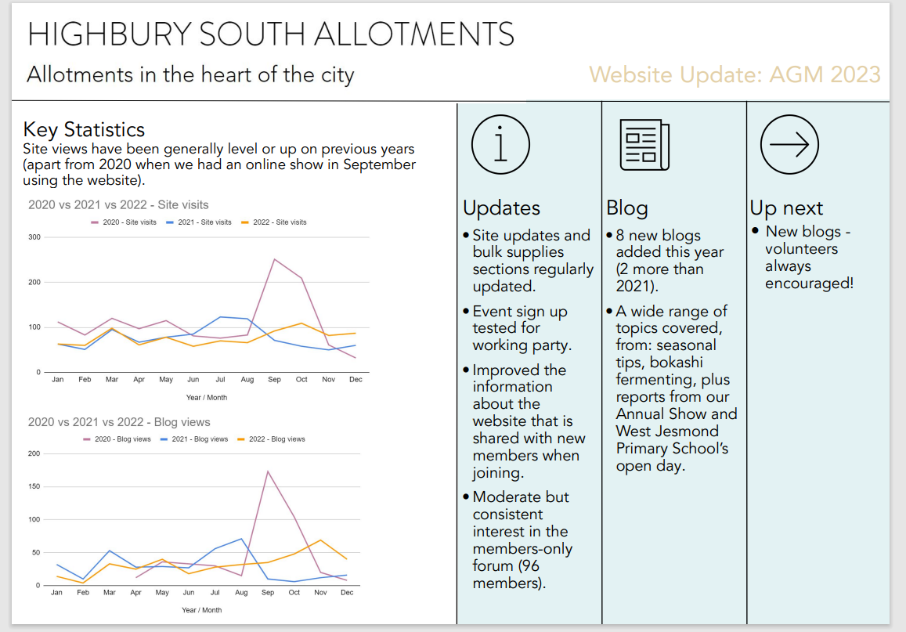
Tim and Jo reported an increase in blogs and visits to the website and there are now 96-100 members signed up for the forum which is the area for members-only. Bulk supply deliveries are now posted on the website and forum members notified. The initiative to sign up for working parties etc., will only work if it is universally used. Tim and Jo invited the members to let them have any ideas or blogs they would like to see on the web-site.
Bob noted that the web-site was very valuable for our external profile.

Grass Cutting, equipment and site infrastructure report 2022.
Chris Sutcliffe

The two strimmers and two mowers have been well used by the membership throughout the year and apart from the occasional breakdown have only required the usual annual service attention. We have also added a new electric strimmer for lighter strimming requirements. This strimmer is kept in the lockup and Pam kindly looks after the battery charging. If you would like to use it please contact Pam by email and she will arrange a convenient meeting time and place to hand over the battery. Please be aware that this strimmer is designed for lighter applications such as grass borders and less woody undergrowth - please use the heavy-duty petrol strimmers for thicker denser undergrowth. David suggested the purchase of a spare battery.

After using any of the equipment do fill in the equipment log and report any issues. I do regularly check the logbook but if there are any issues (including low fuel level) it would help if you could email either Pam or myself (chrissutcliffe@me.com) with details. Chris will add his email to the logbook.

Cutting of the smaller paths is somewhat sporadic and although we do not advocate neatly manicured paths, please do monitor the paths in the vicinity of your own plot so that access remains unhindered. However, if appropriate, ease back on some grass cutting where wildlife thrives in longer grass.

If you need a key for the lock up there is a list of keyholders on the allotment website and on the noticeboards.

Shredders – Chris reported it was approximately £120 to hire a shredder for the weekend in order to reduce the need for fires and create our own woodchip.
Fires - Chris plans to put up a windsock at the Highbury South gate and print some advice on the noticeboard regarding the use of fires.

We suffered two big storms earlier in the year and a lot of damage to the perimeter fence particularly along Highbury and Highbury field. Fortunately, we were able to organise two teams at the working parties to repair the broken sections of fence which proved to be a great success and was also a lot cheaper than getting contractors in to carry out the work.

We were also subject to a series of incursions in the summer months with some associated mindless vandalism and we will be planting “security hedging” along the more exposed sections of fencing in an attempt to deter any further break ins. We also changed the gate keycodes in case they had been compromised. We will never be able to make the allotment totally secure and our proximity to Highbury field makes us particularly vulnerable to such forays. If any member sees anything suspicious, please do report it to Stephen via Pam, the membership secretary.

Finally, a big thank you to Phil Leonard for his hard work maintaining and repairing the ride on “Bucking Bronco” mower and for keeping the main paths in good order.

A member noted the north gate is sometimes not locked and Chris explained that the handle must be released down carefully for it to be firmly closed.

West Jesmond School and Community Garden: AGM report, January 2023
Tim Cook

This has been another successful year for the school allotments, made possible as always by a group of dedicated volunteers led by Jenny Wigston and Joan and Gavin Aarvold to whom the school owes an enormous debt of thanks for their continuing efforts. There is a core of 12-13 volunteers who work every Wednesday.
Weekly visits continue to be made by classes in Years 3 and 4 with only a brief pause in January for essential maintenance and cleaning of greenhouses. Class visits will resume on Jan 25 when the children will begin sowing this year’s produce.
The school has begun to include where possible produce from the allotment in our school dinner menus to give children direct experience of the journey our food makes from ‘seed to plate’.
Children are now enjoying activities around our new fire pit, and we’d like to thank the committee for agreeing to this innovation.
Highlight of the year was our school allotment open day in May which attracted approximately 250 visitors, many of whom were parents of school children visiting the allotment for the first time. The site also had a visit from Gosforth middle school.
The date for this year’s open day is planned for Sunday 7 May and further steps will be taken this year to ensure that access by visitors is limited to the school plots.

Election of officers and Committee
Bob asked if anyone wished to put themselves forward for one of the committee roles. As there were no replies Bob suggested that, as the current officers were happy to continue for another year, the officers would be duly elected unless there were any objections. There were no objections.
Bob Heyman – Chairman
Stephen Tyrer – Secretary
Roger Blight – Treasurer
Pam Brown – Membership Secretary
Tim Parsons and Jo McSwaine – Web-site management
Chris Sutcliffe – Equipment
Bulk Supplies – Olga McFall
Mark Homer - Fire Officer
Tim Cook represents West Jesmond Primary School.

All officers are welcome to be on the committee but do not have to be.
Bob invited all present to get in touch if they were interested in joining the committee. They would be welcome to join without committing to a specific role and to see if they may want to take on an officer’s role in the future. Looking forward, David suggested it was preferable to have more people on the committee.

Rent for 2023
Roger put forward the options of leaving the rent as per 2022, increasing to £46 per half plot or a 10% increase to £48. A 10% increase was approved given the unknown rent due to the Freemen, already one invoice in arrears, and the additional fencing / shrubbery required to secure the site as well as the need for a reserve for potential drainage repairs not covered by Northumbrian water.

Discussion took place and the motion was then approved by the members as follows:
26 voted for a 10% increase, and 2 against.
Thus, the new rents for 2023 are: -
Full Plot from £88 to £96
Half Plot from £44 to £48
Quarter Plot from £22 to £24

Pam will forward the new rental costs and payment methods to the membership.

Any other business.
Grants – Bob explained that there was an opportunity to apply for a £2k grant, and that shrubs for the perimeter were one possibility. One member suggested including blackthorn, and planting wildflowers around the edges of the site. This suggestion was welcomed, although, from experience, Chris pointed out the difficulty of preventing the wildflowers being overwhelmed by weeds.

Bob thanked Mark Homer for volunteering to be the new fire officer and agreed there was no need for him to attend committee meetings.

A member asked where the rules were regarding fires. The rules are visible on the website although the latest complaints from neighbours may result in changes to the current rules, see above.

Stephen confirmed that there had been no communication between Urban Green Newcastle and our Association regarding the tree planting on the Highbury field. A member voiced concern over the shading that would inevitably happen in coming years. Stephen agreed to write again to request that the trees should be managed to a limited height to avoid shading Highbury plots on the southern border. It was suggested that the local councillor should also be approached as communication with the Freemen is difficult.

A member asked about rat control. David Callan, who took a full day’s training, is authorised to provide a specific poison which is a very fast working and significantly reduces the danger to other creatures.

Concern over the cost of skips was voiced and a member noted that metal could be removed without charge to our Association. It was agreed that the Association will contact external removers to take away any metal from the site thus reducing the hire costs of skips in the long-term.

Two member voiced concern over dog waste on the site, a problem which appeared to have got worse. It was agreed that signs should be erected at both gates reminding members that they must keep their dogs on a lead and pick up after them.

Bob thanked everyone for attending and to Meryl for co-ordinating the raffle, which raised £50.

The meeting closed 21:10.

